1. To access any web service AWS offers, you must first create an AWS account. You can create free account at <https://aws.amazon.com/free>
2. It has 12 months free service

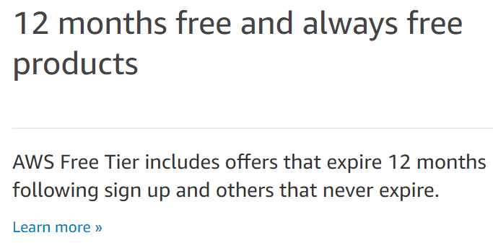

1. It has many services but one we are interested is free EC2 instance – t2.micro.

Amazon EC2 (Amazon Elastic Compute Cloud) is a web service that provides resizable compute capacity in the cloud. We can think of it as a cloud/virtual computer. We will be using this to install Jupyter Notebook, Spark etc

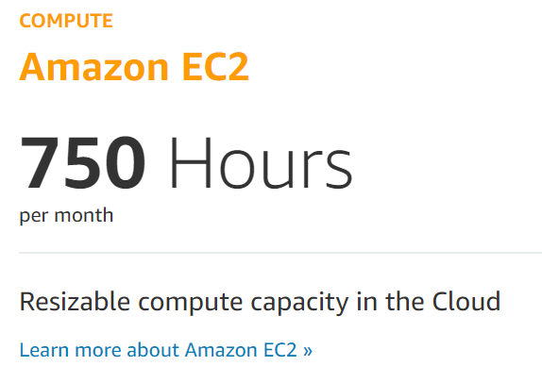

1. Lets first signup with email address and fill out the profile information
2. Provide profile information. It consists:
   1. Contact information – Provide basic contact details here
   2. Billing information – Need to provide CC here in case you go over the free limits. Amazon will charge after 12 months of service or using more than 750 hours of EC2 instance
   3. ID verification
   4. Choose free support plan
3. Provide above information and create free aws account. Next step will be creating EC2 instance